**LINUX BOOTING PROCESS**

The Linux booting process is a sequence of steps that occurs when a computer system is powered on or restarted. It involves loading the operating system kernel into memory, initializing hardware components, and launching system services and user-space processes. below is an extensive explanation of the Linux booting process:

## Stages of Linux Boot Process (flowchart)

* BIOS Stage
* Boot Loader Stage
* Kernel Stage

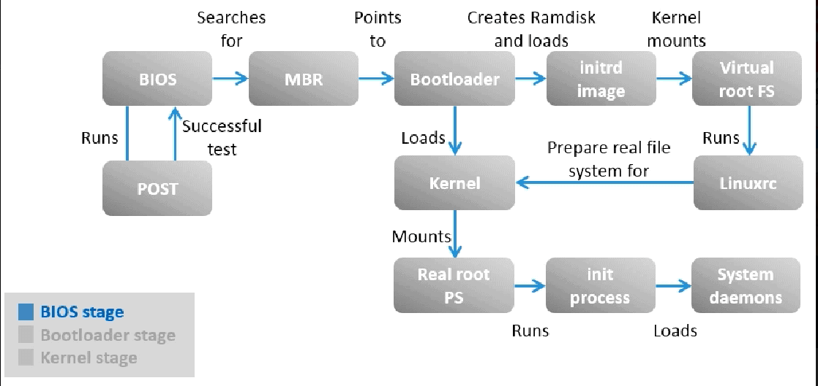

## BIOS Stage

1. When the machine is powered on **[BIOS](https://www.golinuxcloud.com/dmidecode-command-in-linux/" \o "20 dmidecode command examples in Linux [Cheat Sheet]" \t "/Users/mac/Desktop/Devops/Devops-thebulb/x/_blank)** is the first one to be called to verify if the hardware is present in the machine and if it is functioning.
2. This is done by performing a ****Power On Self Test**** (POST)
3. After a successful test, ****BIOS checks the MBR**** (Master Boot Record) in the hard disk to check if it refers to the location of the boot loader.

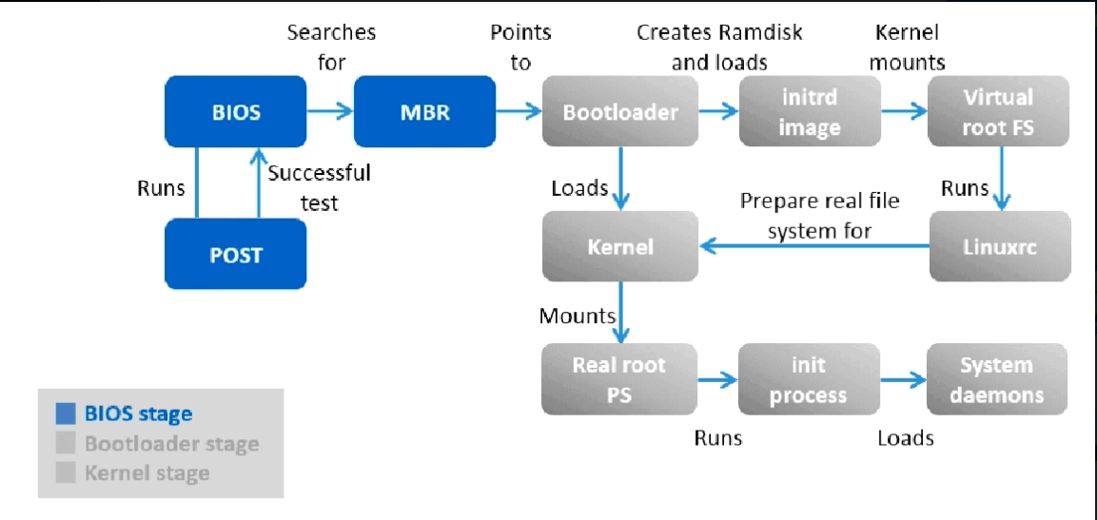

## 2. Boot Loader Stage

The boot loader will be installed if an operating system is installed on the system.

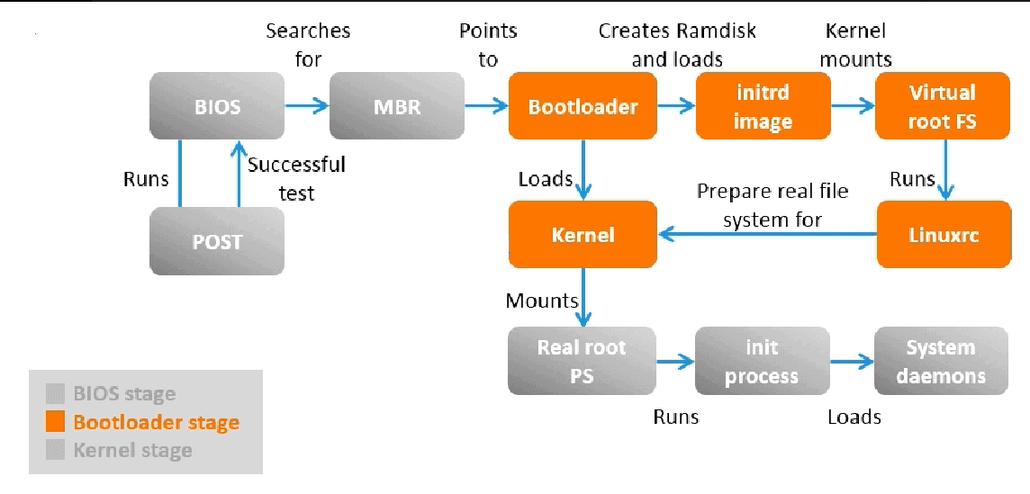

1. The****boot loader**** will present the user with a list of menu entries, each of which corresponds to different operating system.
2. The boot loader will then start to boot the operating system.
3. When you select the the option to start Linux, it decompresses the Linux kernel in memory.
4. After that ****Linux kernel****(which you selected to boot from)****loads initrd**** (Initial ramdisk).
5. The initrd is used by the Linux kernel as a temporary filesystem in the memory.
6. It contains tools and kernel modules which will continue the boot process including ****mounting a virtual root file system**** temporarily.
7. Instead of using initrd, some Linux filesystem will also use ****initramfs****.
8. It serves the same purpose of initrd, it is just that it is a successor of initrd.
9. ****linuxrc is an executable file that is next spawn****, it probes the mass storage hardware and finds a suitable kernel module to drive the mass storage hardware.
10. This is required to prepare the ****real root**[filesystem to be mounted](https://www.golinuxcloud.com/linux-mount-command-iso-usb-network-drive/" \t "/Users/mac/Desktop/Devops/Devops-thebulb/x/_blank)**by the Linux kernel****

## 3. Kernel Stage

1. In the kernel [stage of the Linux boot sequence](https://www.golinuxcloud.com/read-user-input-during-boot-stage-linux/" \t "/Users/mac/Desktop/Devops/Devops-thebulb/x/_blank), the Linux kernel based on the result of ****linuxrc can then mount the real root file system.****
2. The real root file system in Linux is referenced as "/" and it is where all other sub directory and files visible when Linux is running exist.
3. The kernel will then ****spawn the init process****, this process always has the process identifier (PID) as "1" because it is the ****first background process or daemon started by the kernel upon boot.****
4. All other ****background daemons are spawned from the init process.****
5. So the init process will load other system daemons depending upon the configuration of different runlevel

